Important Reminders

* **June 4th – No School**
* **June 6th – No School for students**
* **June 11th – No School for students**
* **June 12th – Field Day**
* **June 26th – Last Day of School** 
  + **½ day**



**Math**

**This moth students will be finishing up the measurement chapter and moving on to area and perimeter. Students will learn how to calculate the area and perimeters of both regular and irregular shapes.**

**Word problems are an important part of our curriculum! We use the Problem Solving steps as a tool to help guide the students through the word problems**

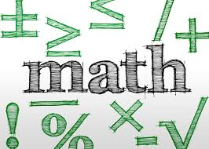

**Content**

**Social Studies**

**We will be focusing on local and state government of the United States, as well as learning about the Constitution**

**Science**

**We will be finishing up learning about how vision and light works.**



**It has been a very busy, productive, and fun year. We enjoyed teaching and learning with your children. We wish you all a wonderful and safe summer break.**

**-The Fourth Grade Teachers ☺**

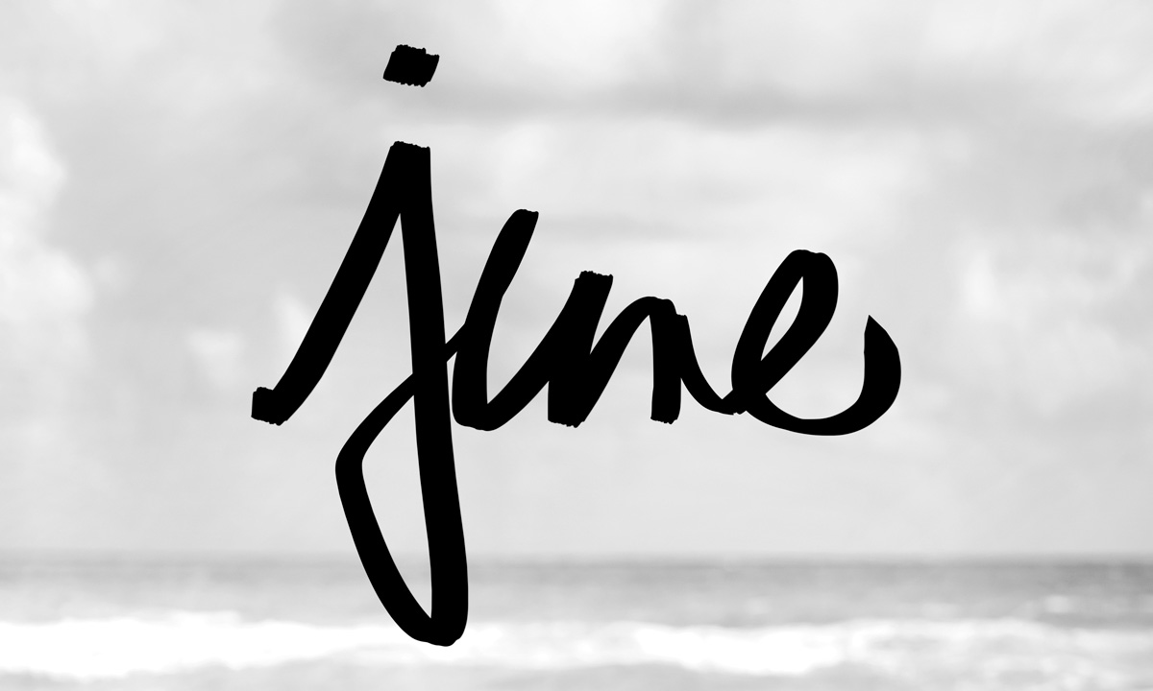

English Language Arts

This month we will launch power and perspective unit. Throughout this unit students will read a text with two specific lens, the lens of power, and the second lens of perspective. Students will work on critical thinking skills which will help them become active and questioning readers.

Writing

This month students will be working on the very exciting and fun graphic novel unit. Throughout this unit, students will plan, create, draft and publish graphic novels with characters that are complex.



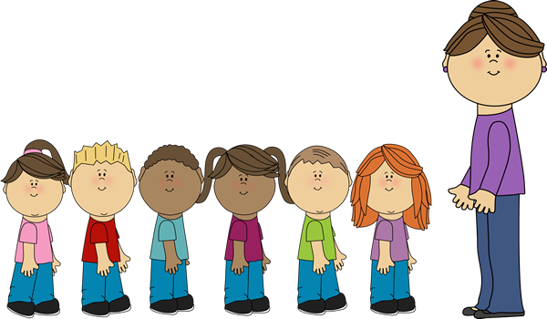Fourth Grade News